**Auto Date Stamp Function in Adobe Pro**

This function is ONLY available in Adobe Pro (paid version) which the unit has 2 licenses for. One is on the unit’s laptop and the other on the SST’s PC. This will work to combine Word, Excel, Power Point, JPG, PNG, GIF or just about any file type we normally see.

1. Get an email that has attachments
2. Save the attachments to the network in the G:\Provider Certification & Compliance\Auto Date Stamping in your folder (everyone should have one)

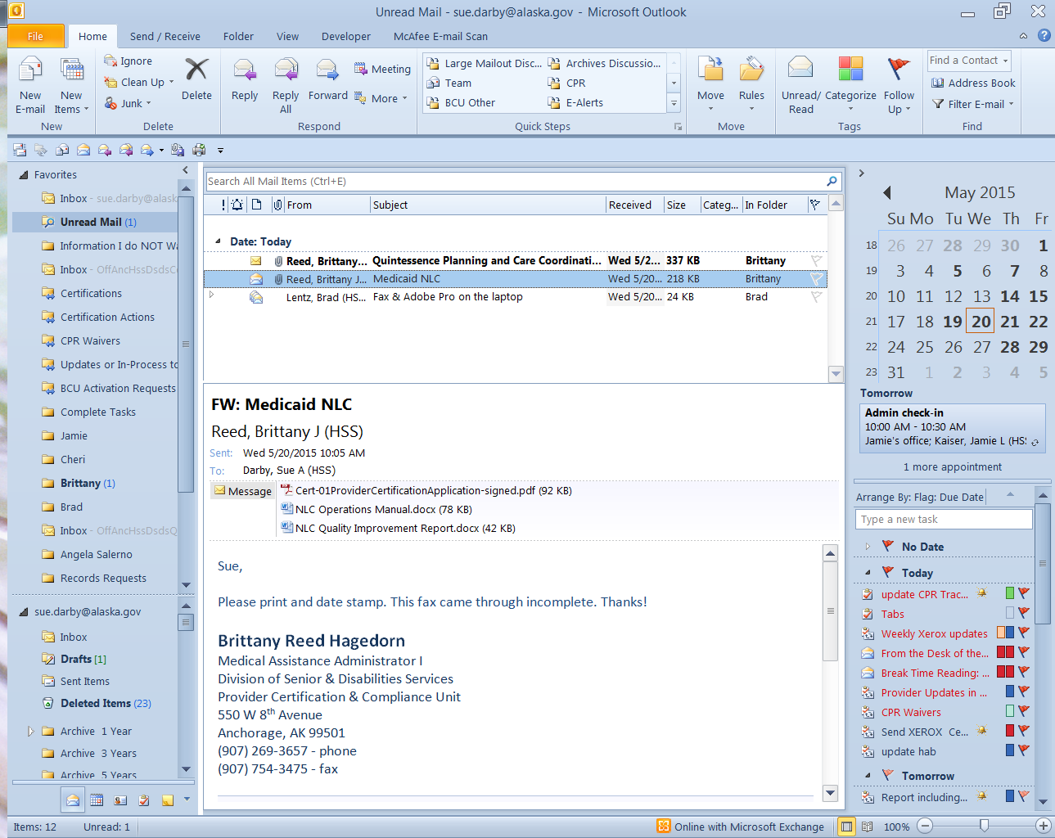

1. Navigate out to the folder on the network while on the laptop
2. Select all the files you wish to date stamp and RIGHT click and Combine files in Acrobat

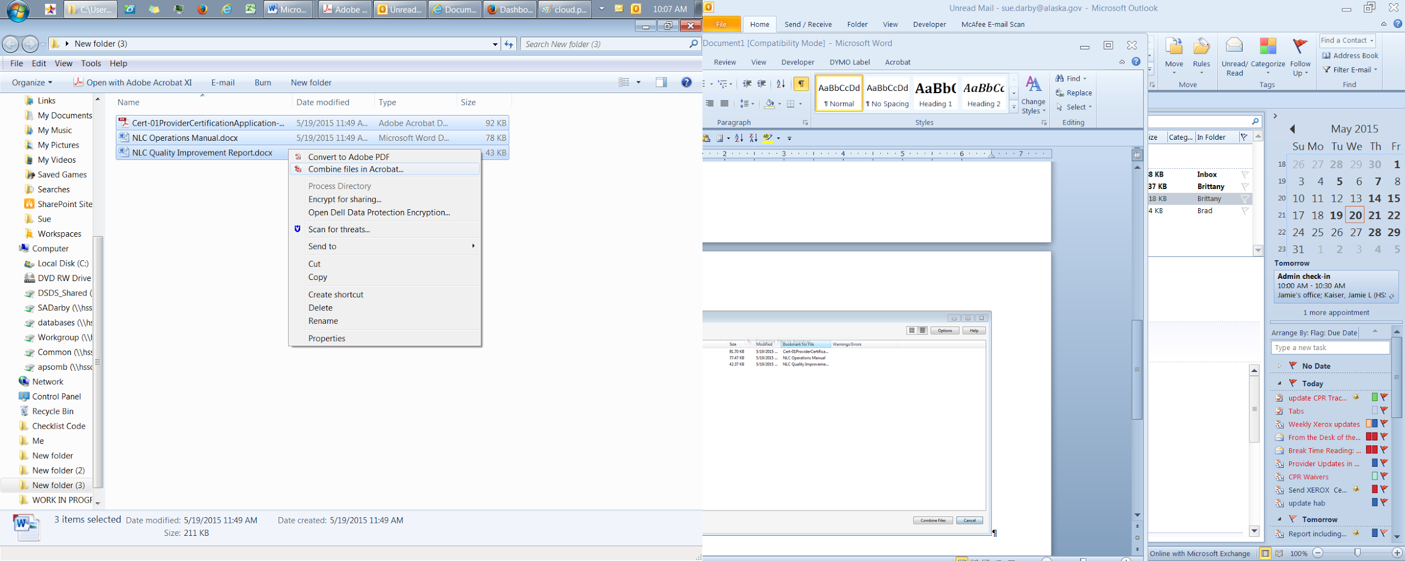

1. You have the option to move the files around if you want them in a specific order from this screen otherwise click Combine files

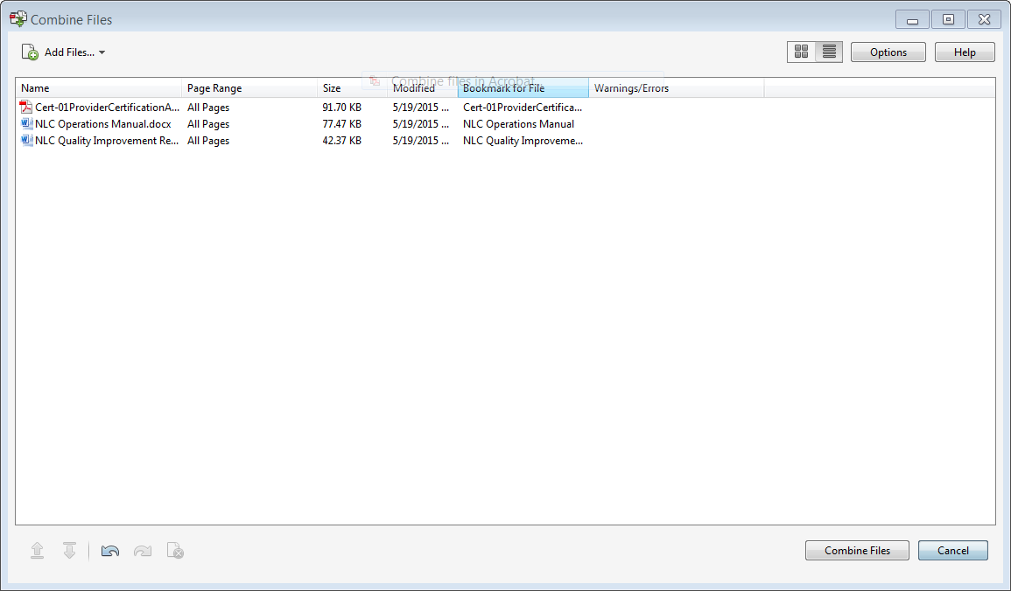

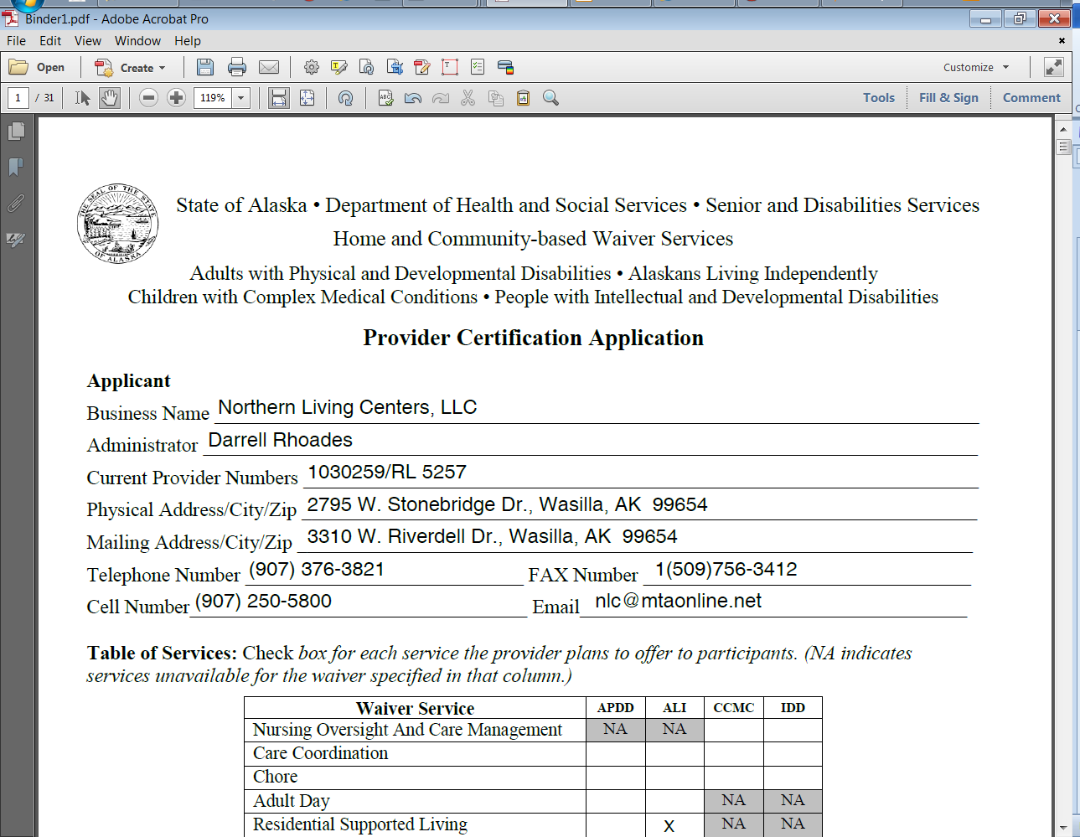

1. You now have one Binder document with all the pages from all the files you selected

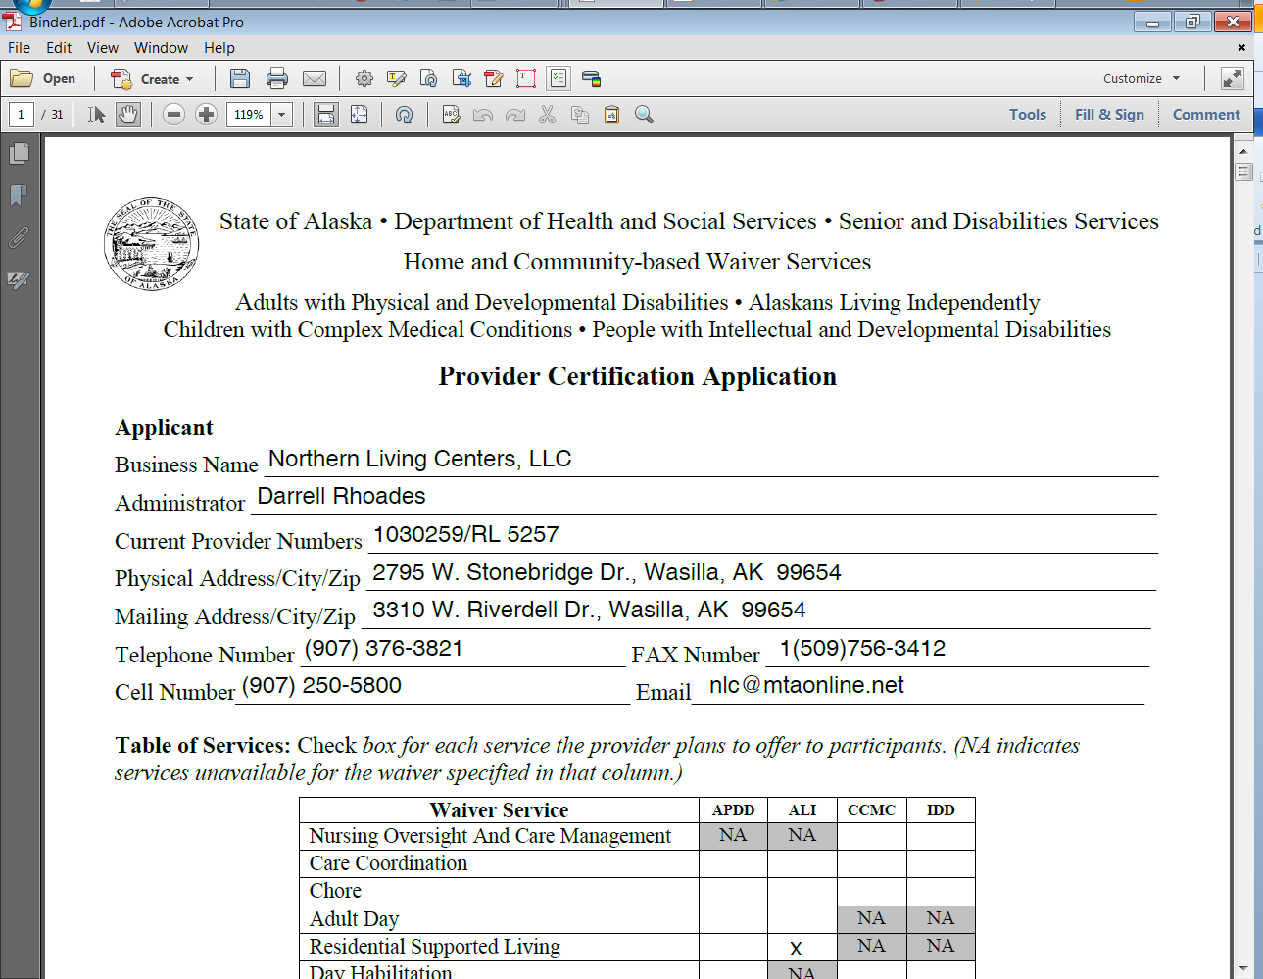

1. Click the above button found on the menubar to start the Wizard for date stamping
2. The following side bar will pop out on the right side of the screen simply click Start

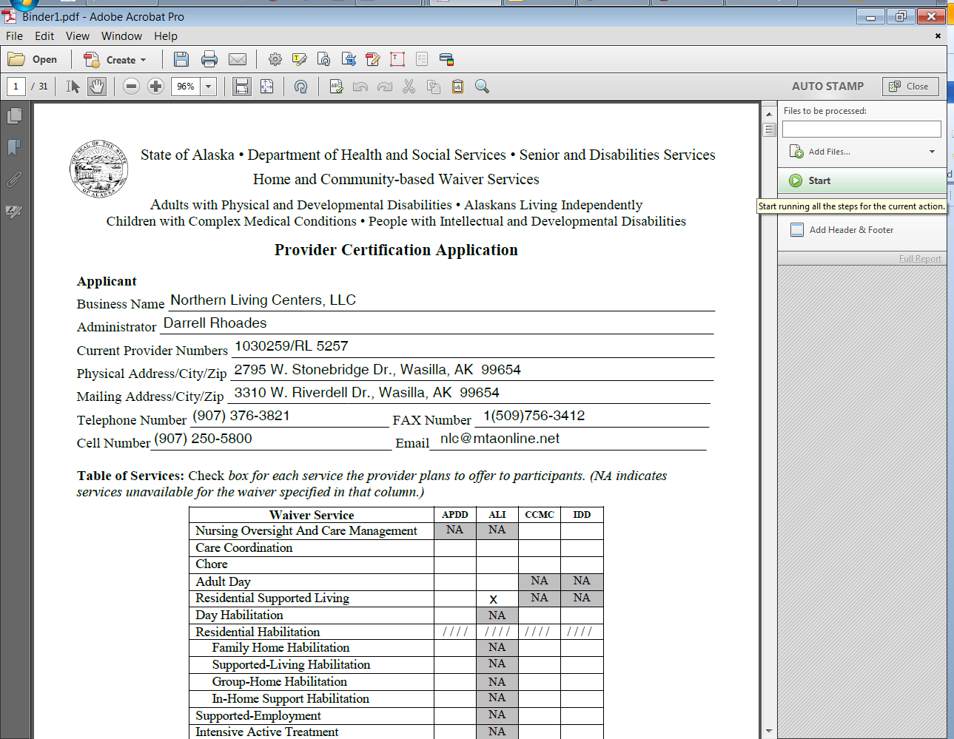

1. You will likely see this dialog box simply save the binder in the folder you you’re your originals in as follows.

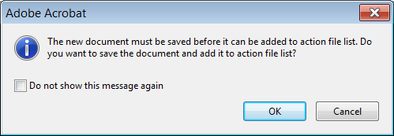

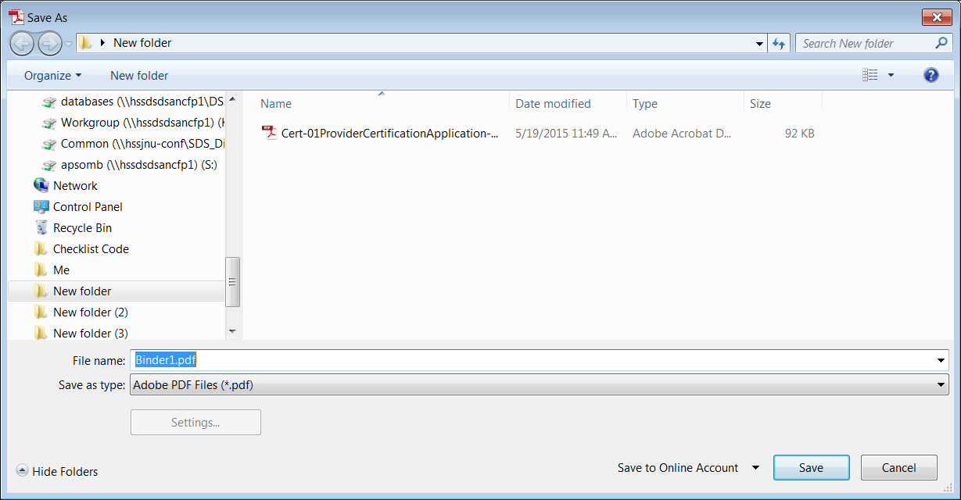

1. You will now have the option of replacing the footer or adding a new footer. Depending on the document you have either will work. Replacing will eliminate the current footer and simply have out date stamp on bottom. Adding a new one runs the risk of having multiple layers of text one on top of another.

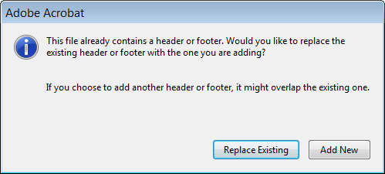

1. The text and date will be presetup and the only thing you will have to add is the current date in the center box of the footer

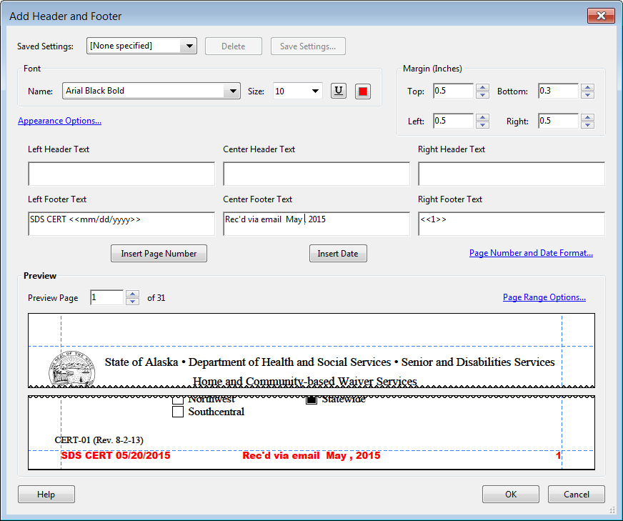 Before date

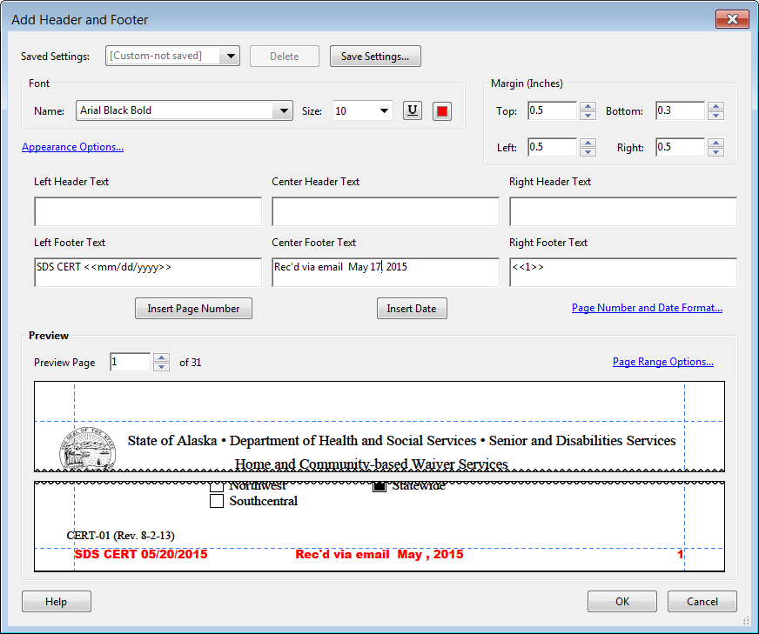 After date

1. Once a month the name of the month will need to be updated

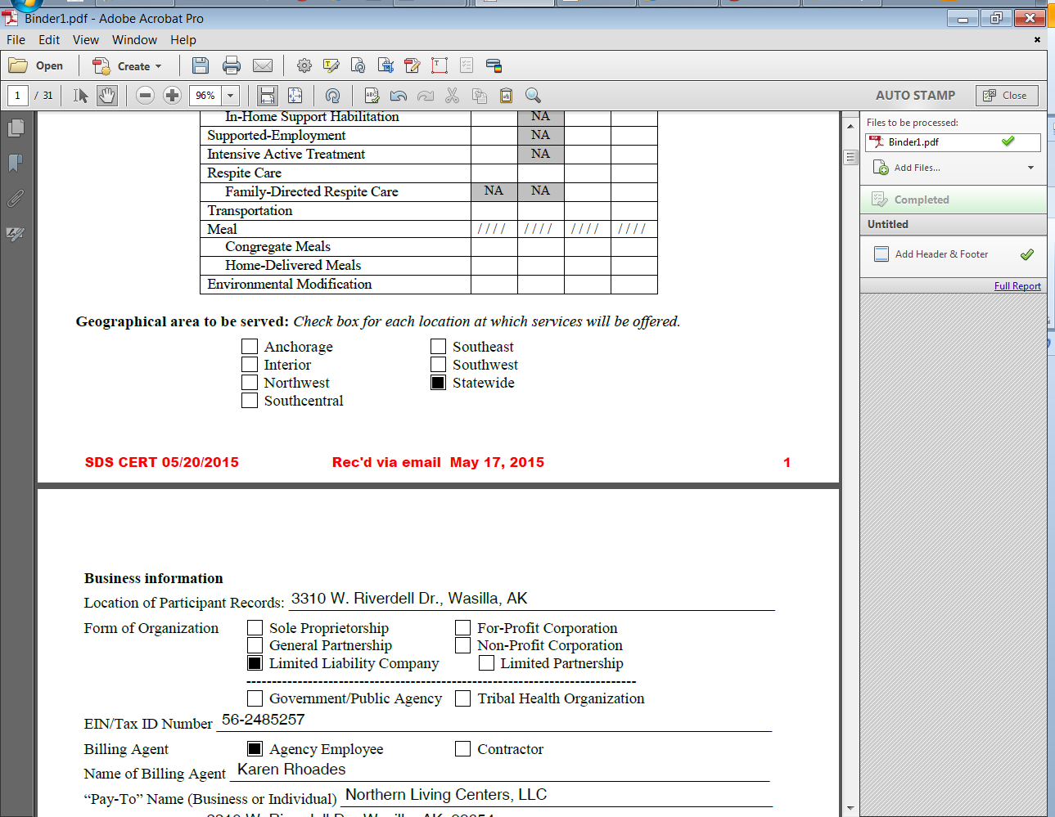

1. Once you click OK you are now ready to print with the ready to go date stamped footer and page numbers
2. You can delete the saved attachments after you are done printing